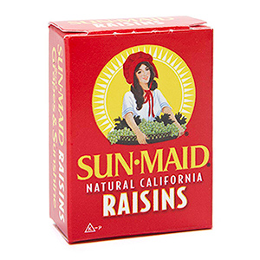
Hauntingly Healthy Snacks
From PARENTS Magazine written by Raven Snook
Copyright © 2011 Meredith Corporation.
You don't need doctors to tell you that all the candy corn, chocolate, and other high-calorie goodies your kids collect at Halloween aren't healthy -- but they're happy to remind you. "Given our nation's alarming rates of obesity and hyperactivity, gorging on candy isn't smart and sends the wrong message," says Jessica Grant, M.D., of West Care Pediatrics in New York City. To stop the sweets overload this Halloween, consider handing out healthy snacks and nonedible treats like crackers, miniature toys, and temporary tattoos -- items you might find in a typical goody bag. Even if you risk provoking an eye-roll or two from trick-or-treaters, these alternative Halloween treats are creative ways for kids to celebrate the holiday without adding to the sugar rush.
Cut down on the empty calories and sugar by giving out sensible snacks, like candy's close cousin, sugarless chewing gum. "It's a natural cavity fighter," explains Philip Schnall, D.D.S., of Schnall & Farkas, a dental care practice in New York City. "Chewing stimulates saliva, which fights tooth decay." Mini boxes, bags, and packages of raisins, apple slices, pretzels, string cheese, cereal bars, Goldfish crackers, and Pirate's Booty are easy to find at the local supermarket -- and are well-liked by kids. Or hand out Halloween-themed bags of baby carrots (BabyCarrots.com has packaged them as Scarrots) or Angie's Kettle Corn, which is gluten-free.

